12.55: In terms of the density 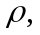the ratio 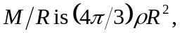 and so the escape speed is

